**Name: KAMCHE YANN ARNAUD**

**Matricule : FE21A208**

**Department: Computer Engineering**

**Level: 300**

**Task: Implement a queue using array**

1. **CODE**

/* IMPLEMENTATION OF QUEUE

Using Arrays

10/20/2022

*/

#include<stdio.h>

#include<stdlib.h>

#include<conio.h>

#define MAX_SIZE 100

int A[MAX_SIZE];

int front = -1;

int rear = -1;

int result;

void Create(int Queue_Size)

{

int A[Queue_Size];

return;

}

//Queue is Full

void Queue_Full()

{

printf("Error: QUEUE OVERFLOW\n");

return;

}

//Queue is Empty

void Queue_Empty()

{

printf("Error: QUEUE EMPTY\n");

return;

}

/*Enqueue inserts an element into the queue

Elements are inserted from the rear.

The are three conditions to check in this case, which are:

- Is the queue full, if yes display the state of the queue being 'FULL'

- Is there only one element, if yes, both the front and the rear will automatically

acquire the index of the first position in the queue.

- Are there more than one element, if yes, increment the rear in a modulo fashion and insert an element

*/

void Enqueue(int max_size, int element)

{

int index;

index = (rear + 1)%max_size;

if (index == front)

Queue_Full();

else if (front == -1 && rear == -1)

rear = front = 0;

else

rear = (++rear) % max_size;

A[rear] = element;

return;

}

/*Dequeue removes or pops an element out of the queue

Elements are removed from the front

There are three conditions to check in this case, which are:

- Is the queue empty, if yes, display the state of the queue being 'EMPTY'

- Is there only one element in the queue, if yes, both the rear and the front

will acquire the null index(-1), signifying that the queue is empty

- Are there more than one element in the queue, increment the front.

*/

int Dequeue(int max_size)

{

int index;

index = front;

if(front == -1)

return 0;

else if(front == rear)

front = rear = -1;

else

front = (front + 1)% max_size;

return A[index];

}

//Display: Prints the content of the queue

void Display(int max_size)

{

int i;

i = front;

if( front == -1 )

Queue_Empty();

else

{

printf("Queue: ");

do

{

printf("%d ", A[i]);

i = (i+1)%max_size;

}while ( i != rear);

printf("\n");

}

return;

}

//headOfQueue: Displays the element at the front of the queue

int headOfQueue()

{

if(front == -1)

return 0;

else

return A[front];

}

//endOfQueue: Displays the element at the rear of the queue

int endOfQueue()

{

if(rear == -1)

return 0;

else

return A[rear];

}

//sizeOfQueue: Displays the size of the Queue

int sizeOfQueue()

{

if( front ==-1 || rear == -1)

return 0;

else if(front < rear)

return rear - front +1;

else

return front - rear+ 1;

}

void statusOfQueue(int size)

{

int index;

index = (rear + 1)%size;

if(front == -1)

Queue_Empty();

else if (index == front)

Queue_Full();

else

printf("STATUS: Not Empty");

return;

}

int main()

{

int Queue_Size, choice, num;

system("color 2");

printf("Enter the size of your Queue: ");

scanf("%d", &Queue_Size);

Create(Queue_Size);

printf("1. Enqueue\n");

printf("2. Dequeue\n ");

printf("3. Head of queue\n");

printf("4. End of queue\n");

printf("5. Display Queue\n");

printf("6. Size of queue\n");

printf("7. Status of queue\n");

options:

printf("\nChoose the operation to be performed with your list: ");

scanf("%d", &choice);

while(choice == 1|| choice == 2|| choice == 3|| choice == 4 || choice == 5 || choice == 6 || choice == 7)

{

while(choice==1)

{

printf("Enter a number: ");

scanf("%d", &num);

Enqueue(Queue_Size, num);

goto options;

}

while(choice == 2){

result = Dequeue(Queue_Size);

if(result == 0 )

printf("Queue is empty");

else

printf("%d", result);

goto options;

}

while(choice == 3){

result = headOfQueue();

if(result == 0)

printf("No Element at the front");

else

printf("%d", result);

goto options;

}

while(choice == 4){

result = endOfQueue();

if(result == 0)

printf("No Element at the end");

else

printf("%d", result);

goto options;

}

while(choice == 5){

Display(Queue_Size);

goto options;

}

while(choice == 6){

result= sizeOfQueue();

if(result == 0)

printf("Queue is empty");

else

printf("%d", result);

goto options;

}

while(choice == 7){

statusOfQueue(Queue_Size);

goto options;

}

}

return 0;

}

1. **COMPILATION RESULTS**
2. **ENQUEUE OPERATION**

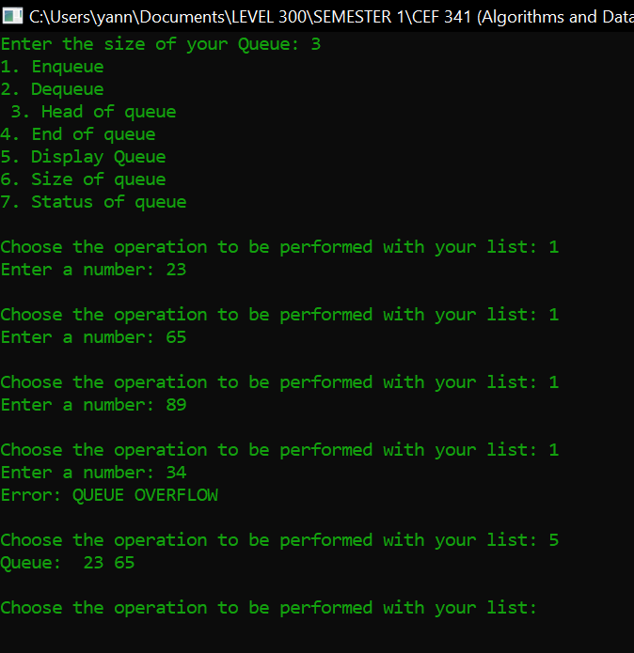

1. **DEQUEUE OPERATION**

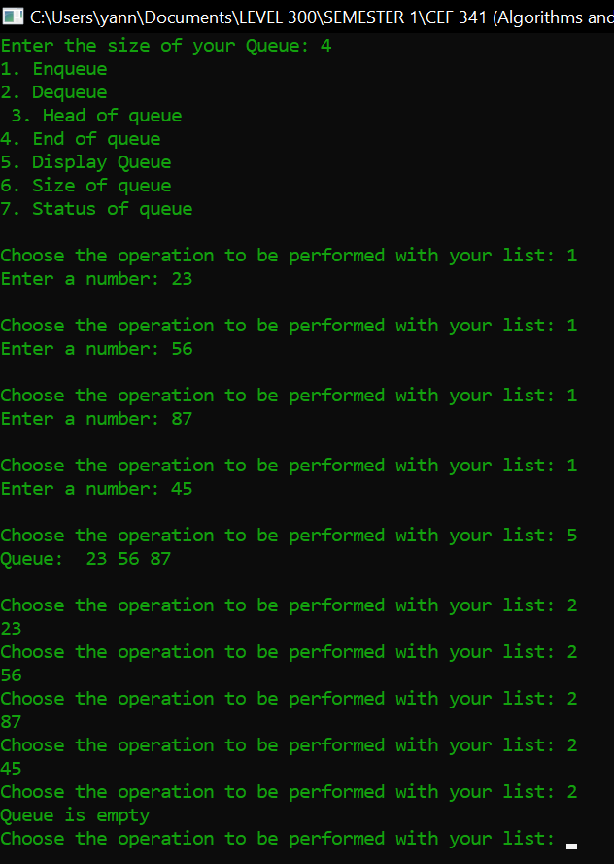

1. **DISPLAY QUEUE**

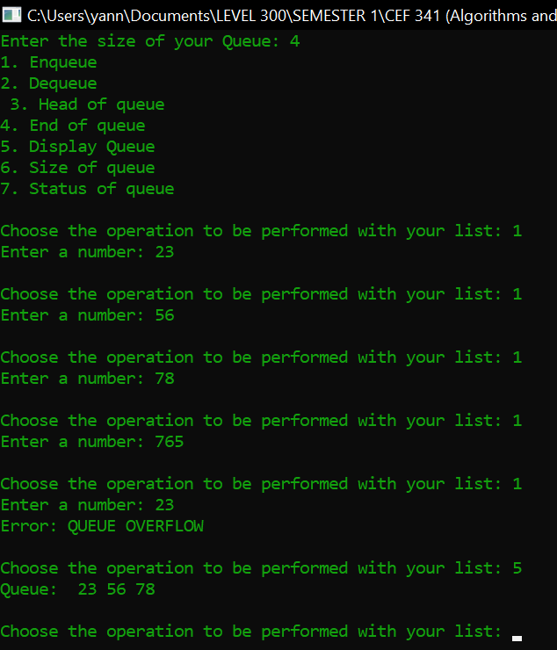

1. **HEAD OF QUEUE**

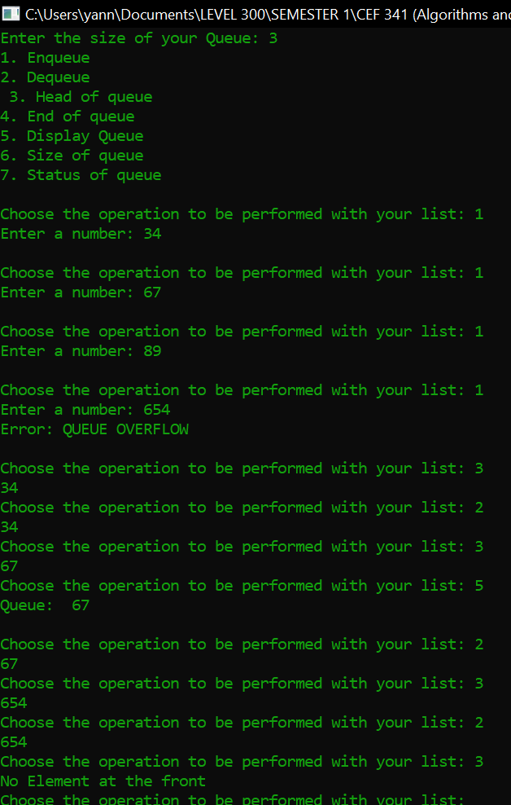

1. **END OF QUEUE**

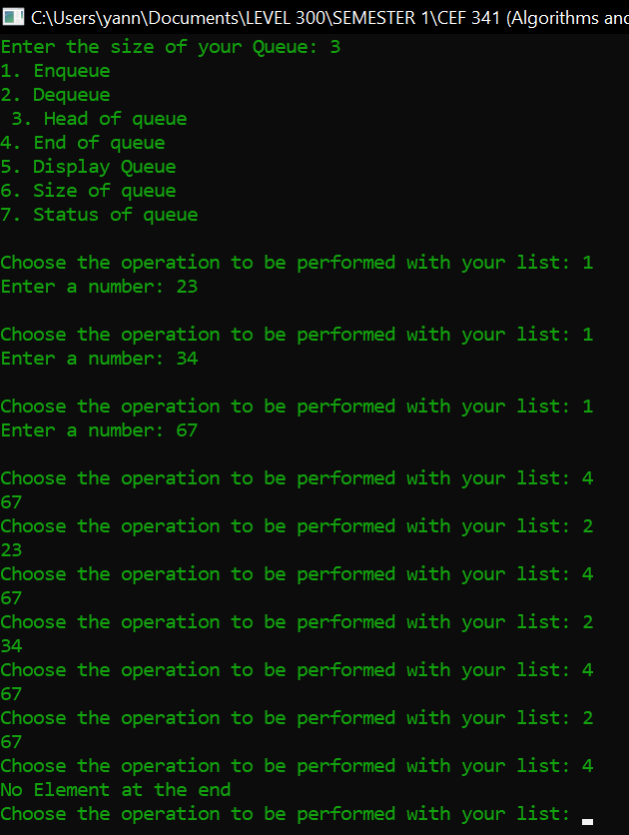

1. **DISPLAY QUEUE**

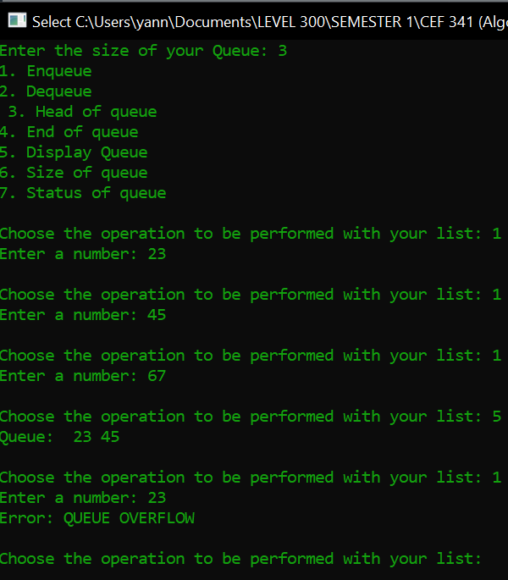

1. **SIZE OF QUEUE**

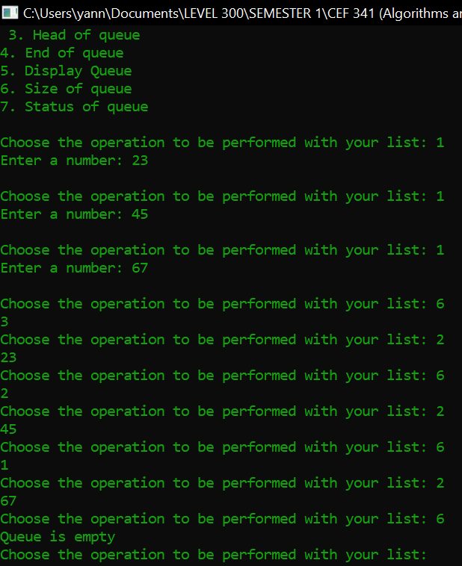

1. **STATUS OF QUEUE**

